**Center reiterates soliciting policies**

Attorney with petitions ousted

June 18, 2024 at 4:00 a.m.

by James Leigh

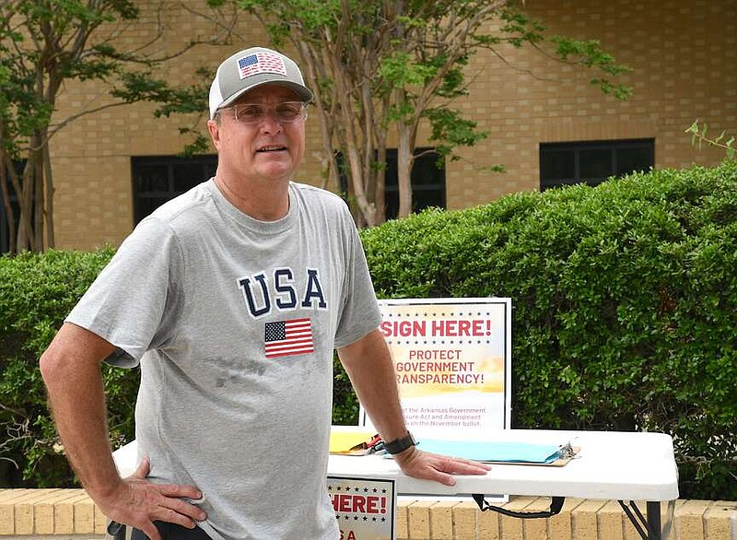Joey McCutchen, a personal injury attorney based in Fort Smith, solicits signatures for a petition for citizen-initiated ballot measures related to the state's Freedom of Information Act outside Hot Springs Convention Center Monday. The HSCC said Monday solicitation is allowed on the sidewalks outside the facility, but not inside the building. (The Sentinel-Record/Donald Cross)

HOT SPRINGS -- The Hot Springs Convention Center is standing by its policy of no solicitation after an incident Friday morning that led to a Northwest Arkansas attorney being escorted from the Arkansas Bar Association's annual meeting.

Visit Hot Springs CEO Steve Arrison said Monday morning that the policy is "pretty standard for buildings."

"All the space in the convention center is rented," he said. "Like this past weekend, the building was fully rented. The lobbies were rented. We had one group at one end of the building, the Bar Association at the other."

A copy of the Hot Springs Convention Center policies and procedures was provided by the convention center Monday.

"The HSCC does not allow any solicitation, including but not limited to petitioning, protesting or picketing on the premises," it said.

Jennifer Standerfer, a Bentonville-based attorney, told The Sentinel-Record on Friday that she had copies of a petition for citizen-initiated ballot measures related to the state's Freedom of Information Act available for people to sign but was not actively soliciting.

ADVERTISEMENT

"I had four clipboards with petitions and set them on the table in front of me," she said.

A statement from the Arkansas Bar Association posted on its website over the weekend said the organization had not requested the removal of Standerfer but had informed her of the policy.

"The Association does not have a written policy about members circulating petitions at its meetings," the statement attributed to Anna Hubbard, the association's publications director, said. "But the Hot Springs Convention Center, which has hosted portions of the ArkBar annual meeting for the last 15 years, does have a policy that prohibits solicitation, petitioning, protesting and picketing on the premises. Throughout the week, convention center personnel had conversations with the ArkBar member about the center's solicitation policy.

"Despite reporting in the media, no one associated with the ArkBar -- staff or leadership -- asked for the member to be removed from the property during the convention. As part of our convention review process, we will be looking into all aspects of Friday's events in detail with our Board of Trustees over the coming weeks."

ADVERTISEMENT

Arrison said the policy is geared "to protect our clients," but if someone cleared it with the group renting the facility, the convention center would allow it.

"At any time had the person gone to the group -- either group that rented the space -- and asked, 'Can I do this?' and the group would have told us, we would have backed off," he said.

"We were not told that. I guess they did not ask for that permission as far as I know. I'm still investigating it. I was here at the very tail end of everything, but I feel very confident that our employees and police department acted in a very professional manner," Arrison said.

Groups that rent the space can ask for the facility's policy to be superseded in certain cases, he said.

"As far as I know, this was not approved by the organization that rented the space," he said. "Then we would look at our policy and say, 'Oh, well, you rented the space. We'll follow your guidelines as long as it's not against the law.' Nothing illegal, obviously, but that permission was not given. We enforced our policy, and we gave numerous warnings over the course of the two days."

ADVERTISEMENT

Joey McCutchen, a personal injury attorney based in Fort Smith, was posted outside the convention center Monday soliciting signatures for the same petition Standerfer had Friday.

"She was handcuffed and led out of a room for having petitions on a table, and somebody comes over to sign," he said.

"But they also told her that she wasn't allowed on this sidewalk right here. So I'm here today to test that theory and see if the city officials want to test that theory because I think it's pretty clear that this is a public sidewalk and that we're allowed to get signatures here," McCutchen said.

Arrison said Standerfer was not told by convention center staff that she could not remain on the sidewalk outside the facility.

"None of my people told her that," he said. "I mean, as long as she wasn't soliciting inside -- I directed her that if she wanted to do that, she could go out on the sidewalk when I talked to her, but that was prior to all that, what happened.

"I informed her of her right to do that when I warned her in that meeting that she was welcome to go outside on the sidewalk with her petition, but she wasn't allowed in the building. That's always where we tell people if they're picketing or protesting -- and I think you can look back at our record with some of that stuff over the years -- that's what we've always told people."

Arkansas Citizens for Transparency said Friday that Standerfer acted lawfully, but was barred from the event and denied the right to collect signatures outside the event on the sidewalk.

McCutchen, who said he had been soliciting for signatures at places all over the state, said he was "just exercising our rights today" to solicit for what he says is the most important law in the state.

"One of the things that I think this initiative has done is highlighted the importance of open government, highlighted the importance of the Freedom of Information Act, and that's what has been one of my missions and goals over the years is to let people know how important the Freedom of Information Act is because it affects every piece of litigation," he said.

"I mean, if you're a Second Amendment advocate, you'd better have open government, because if we don't have the First Amendment, we can kiss the rest of our amendments goodbye. I don't think there's any more important law than (the one) Winthrop Rockefeller passed in 1967 because it affects virtually every city hall, every school board, every quorum court, and we've got to protect it."

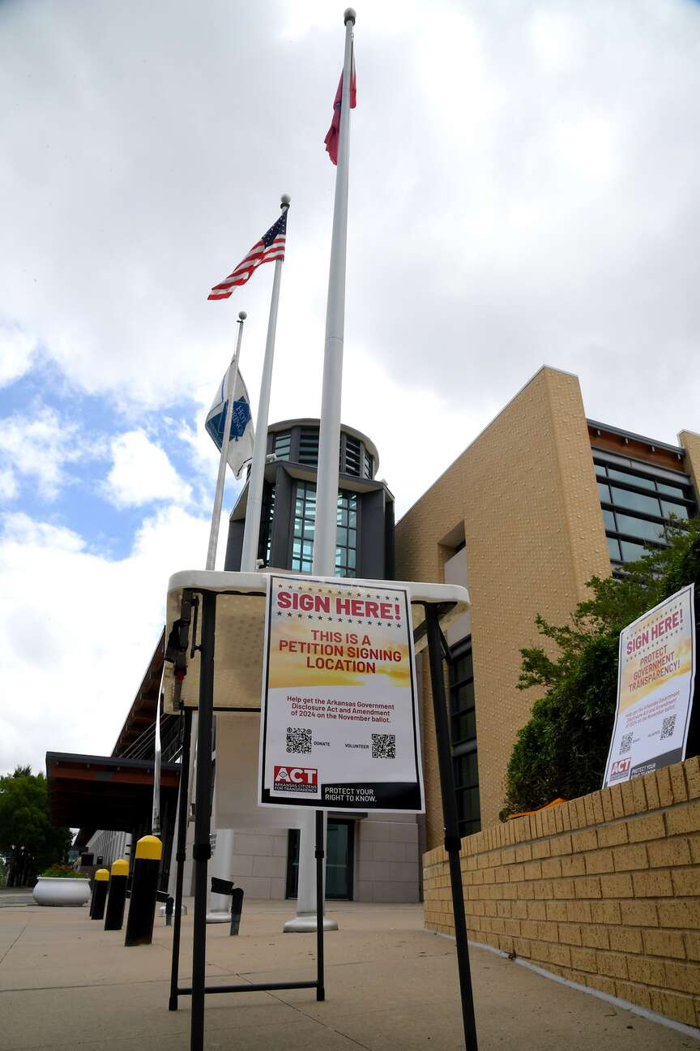 A sign to help solicit signatures for a petition for citizen-initiated ballot measures related to the state's Freedom of Information Act is seen outside the Hot Springs Convention Center Monday. (The Sentinel-Record/Donald Cross)